### My answer to “Doesn't the free market provided by capitalism inherently discourage free and unbiased media (because free market supports greed)?”

Originally answered here: <https://qr.ae/pNbpi2>

[All my other answers linked in this first answer have been included in blog post so one can read uninterrupted]

Many assumptions and emotive cognition here in the question, so putting my views on those as well while answering the question :

1. “**Capitalism has a definition centered around greed” :** This is subjective opinion at best (for both pro and anti “greed” people). What you call greed, other might call self preservation. Capitalism at best means what humans have evolved into after a few millenia. In fact, there is no exact definition of capitalism. pre-1900s Feudalism to 1980/90’s Free Markets to modern bigtech dominance (what some people who dislike it call surveillance capitalism) are all evolution of capitalism based on society. It is an evolving system of incentives and issues. Self Preservation and Passing onto future generation are two constant themes, nothing else. There is no “capitalism manifesto” to define and micromanage how capitalism should work. We see in nature that very greedy organisms get eaten by the surrounding ones and an extremely selfless one withers off. Selflessness which animals show is also part of self-preservation (greed) , as they want a stable society and expect reciprocity in troubles. A complex system like society needs a fine/optimal balance between greed and selflessness to exist, tilt more towards one side and the system either fails or resets or evolves. Society and Economy are way too complex to be defined/run with 5000 page manuals or blanket terms like “Y-isms” and “anti-X”. I will in this question try to explain how I think these modern political concepts have evolved (IMO of course, fully subjective answer) and why news is really just one aspect of short term fixes humans apply to run their society.
2. “**Absolute Free Market can exist” :** Another flawed reasoning in mind of pro free market people is that a free market can perpetually exist. While Adam Smith’s “invisible hand” is an excellent (and probably the best) policy in short term and does increase prosperity for everyone, it is bound to fail in the long term because division of labor (the concept on which free markets work) doesn’t let all sides have equal moats. So people on on side of division of labor are much more susceptible to creative disruption than others. I don’t blame Adam Smith for omitting this caveat in his theory at all because during his lifetime, creative disruption would have taken centuries and this effect would be impossible to notice. However, in modern times, seemingly free markets automatically turn into asymmetrical spaces : [Muktabh Mayank's answer to How does a company that sells a powerful software package like MS Office survive when others offer a free equivalent package?](https://qr.ae/pNFuzc) . *Basically, all I am trying to say is that Free Market does end up creating a hierarchy of more powerful and less powerful* : [Muktabh Mayank's answer to How far can India go to keep the Chinese players, who are well en-trenched in the global tech supply chain, off the Indian market without prejudicing its own growth?](https://qr.ae/pNCyD5) . There was a time when “Libertarianism” was a proper political wing demanding no opposition to free markets. But now Libertarianism has dissolved into either Neoliberalism (no opposition to monopolies) or Neolibertarianism (no opposition to government interference).
3. “**State run systems are somehow less greedy” :** Our friends on the left have another theoretical idea counterpart of free market which is “from each according to their ability, to each according to their need”. We can discuss the merits/demerits of the idea based on whether it is unfair to high-ability people or not, but let’s leave that aside for now and see how idea works in practice. The idea introduces an arbitrary power concept : “the authority to decide who needs what”. So in communist/socialist countries, we dont really eliminate evils of Capitalism, we just introduce a new method to run the power structure, “control of the supply side”. The Socialist/Communist party running the system builds power structures to control the supply side (“who gets what?”). Free Market on the other hand works on “Demand Side” (and powerful people manipulate demand side to get stronger). Free Market works slightly better because a demand based economy is more natural, that’s all. So people with greed will try a different method than manipulating demand in more centralized economies, which is getting more say in authority which controls supply. [Muktabh Mayank's answer to Is capitalism a long-term solution? Or is it temporary till technology can be used to control people's greed and then communism can be established?](https://qr.ae/pNofjj) . Please understand that nor was Communism thought about with intention to create a power center like Feudal systems have (it in fact had the intention to decentralize power to workers), neither was free market thought about to give rise to the [1% rule (Internet culture) - Wikipedia](https://en.wikipedia.org/wiki/1%25_rule_(Internet_culture)), but intentions dont matter ! Incentives do and there is no way someone thinking about a new ideology can model all these scenarios. There is just no perfect political/economic philosophy. Everything is a tradeoff. But remember, whatever political philosophy you adopt, you cannot stay away from the two evolutionary traits of 1. Self Preservation and 2. Desire to do good for progeny. *In your words, you cannot get rid of “greed” even if you run away from capitalism, its much deeper than that*: [Muktabh Mayank's answer to Does communism inherently benefit from war as capitalism (unfortunately) does? Wars have previously boosted the economy of capitalist countries.](https://qr.ae/pNuKHE)
4. “**Unbiased press exists/can exist under some scenario”** : If you have read this long theoretical and subjective answer (and maybe my other linked answers !) till here, I think I would have convinced you that you cannot really run away from power structures (hierarchies) and greed. They are just how humans aggregate as society (or in any group). At best, you can try to make them more fair. The spread of information (which you can call news between 1900s-2010) is the most important way to exercise the power human hierarchies have. So news has always been and will always be “biased”. Its either biased towards people at top of hierarchy or ones who can possibly displace them. [Muktabh Mayank's answer to Is artificial intelligence already controlling us in the form of tech giants manipulating people via algorithms?](https://qr.ae/pNwcan) . Humans are extremely local creatures and they can only look into their intermediate surroundings and make logical decisions. To look beyond that, they depend upon what information is conveyed to them. Most of them will just depend upon processed opinions/statistics from trusted sources, others will try to read into patterns from facts. But there is just so much information out there ! You don’t even need to spread mis-information to build a narrative, you just can pick-and-choose what facts to report out of the available ones to build a narrative. No news organization will choose facts to be reported in random, so the algorithm they use to pick and present facts is what introduces bias.

There is just too many things which happen in real world. History books, epics and biographies were ones the medium to pick-and-choose and then report facts in a way that a narrative can be built for most time in history. Then came the news, after printing press became more common (and then radio waves and TVs). Also there were always hierarchies and power structures amongst humans. It’s no coincidence that facts have been selectively reported all along to preserve such hierarchies.

If you come up with theories like “X,Y,Z-ism caused biased press”, that is just [Confirmation bias - Wikipedia](https://en.wikipedia.org/wiki/Confirmation_bias). With spreading information becoming easier and easier after invention of printing press or private TV or freedom of expression, you now see more and more points of views and thus begin to realize that there is bias in the news. There is very few negative accounts for ancient power structures like say Alexander (unless they had a parallel power structure, like enemies like Egypt and rest of Mesopotamia have talked all ill about Assyrians). Its not like Alexander had no flaws and some US president or Lenin was totally innocent. Its all about who reported what facts.

As and when more information becomes available, society will reset/rearrange itself accordingly : [Muktabh Mayank's answer to Will the 5G internet make this world a chaotic place?](https://qr.ae/pNCZvk) . You can already see that democracy as a system of government has changed so much after main mode of information switched from TV to Social Media. One reason democracy became common when compared to feudalism was because news emerged as the main means to consume information.

I see this trend as humanity handling issue of trust and [Principal–agent problem - Wikipedia](https://en.wikipedia.org/wiki/Principal–agent_problem)

as they develop. t will be very interesting to see how fast data with 5G and tech like AI and blockchain will shape the the world in future.

### My answer to “Is artificial intelligence already controlling us in the form of tech giants manipulating people via algorithms?”

Originally answered here: <https://qr.ae/pNwcan>

AI as of now (and for a foreseeable future) is not cognizant, its just a tool like computers, shovels and engines are. So AI cannot really “control” humans.

This is question on line of “Do guns kill people ?” or “Do crazy people kill other people ?”. The answer to that can be inferred by asking, “Was there no homicide before guns ?” or “will there be no homicide if there are no guns ?”. IMO, guns just make killers more efficient, making them better than killers who do not use guns. You might have a different opinion.

Similarly, tech giants are just using algorithms for the same thing elites before them have been using for a long time to control the window of discourse. Humans are hardly able to understand environment beyond their immediate surroundings and will form an opinion based on how is information conveyed to them. The trick to control window of discourse is selective flow of information. You can change society’s view on things by showing the same thing from different perspectives. Fortunately/Unfortunately, that is how human societies are structured. What tech giants can do however is instead of building general narratives which they need to hammer down into everyone’s mind, they have started personalizing flow of information to individuals using algorithms. This makes them much better at bending and shaping opinion as compared to older methods like Newspapers, TV, Books and Public Announcements.

Social Media/Other bigtech just gives a more efficient method for creative destruction of previous ways to control discourse. That is why you find traditional guardians of public discourse who have not been able to master bigtech blaming it for everything like misinformation to destroying society. Truth is an old guard is slowly vanishing and new one is taking its place.

### My answer to “Isn't specialization in society designed so that we each don't have to research, test, define, and fix everything ourselves? Doesn't this eliminate the need for self reliance for literally everything? Isn't that progress and a good thing?”

Originally answered here : <https://qr.ae/pNz7db>

Given two assumptions, specialization or economic [Division of labour - Wikipedia](https://en.wikipedia.org/wiki/Division_of_labour)

is actually beneficial :

1. The world is static, that is there are no technology or natural disruptions. Or alternatively, all specializations are equal against shock events.
2. Everyone plays fair. That is, division of labor is strictly according to opportunity costs and not aversion to change. In fact, Division of Labor is the practical consequence of opportunity cost. As long as everyone rationally analyzes their opportunity costs and acts accordingly, things should be fine.

Adam Smith’s “invisible hand” is actually our point 2, that is, human intuition of opportunity cost and tendency of most people of to be law abiding. Given a relatively less disturbed country from wars and diseases where there is rule of law, laissez faire should do very well if they can ensure fair play. Pax-Americana {“and Pax-Britanica ?”} are examples that this works for a very long time until the fundamental structure of society starts changing. More fundamentally, specialization is its own enemy as it changes the social structure which wass the reason why specilization was successful in the first place. Let’s try and see the two school of thoughts about why specialization doesn’t scale :

**Humans are not really rational**

However, 2 is almost always violated. Greed/Self-Preservation is not the only emotion that influences human decision making, stability/aversion to change is another one. People tend to be very accepting of their new advantages, but find adapting out of old advantages away harder. So you can see gatekeeping measures like minimum wage or no foreign workers or government subsidies blocking economics to take its true place. So for example some unions would get a minimum wage in place for workers to make sure newer less experienced workers cannot compete with senior people as they cannot be hired at a lower cost. Senior people need consistent money to survive and there are two ways to ensure the money supply : upskilling or minimum wage. Minimum Wage is a more stable and less unknown option than upskilling, so you would see workers union asking for minimum wages, thus changing the opportunity cost metrics. Many from upper and middle class would rather let their old and less lucrative jobs move out of community than providing a way for lower class to take their place by imposing various measures of “quality”. Many elites would practice nepotism and destroy wealth rather than growing the pie. Similarly, you would see countries subsidize their agricultural or traditional economic sectors to make sure someone else doesn’t win the race of division of labor fairly. Most OECD countries have heavily subsidized agricultural sectors making sure the most efficient variant {less specialized jobs moving to economically less well off countries} doesn’t really occur. So essentially, while some countries/communities with privileged have all the labor and earnings because of their power and influence, the others might end up becoming unemployed as they can get no real work. Such unimodal distribution of work is not true ‘specialization’, its just powerful exploiting the weak and weak fighting for misplaced causes. Humans often just want to be confrontational for its sake and portray fights as Zero Sum games where they aren’t.

<http://documents1.worldbank.org/curated/en/888731468331207447/pdf/WPS6963.pdf>

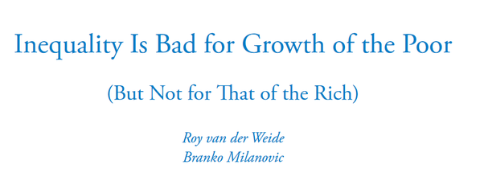

**Ruin is much more powerful than success**

Another {more important} factor against 100% specialization is different divisions of labor have different risk profiles against disruption. While reading the above point, it might have seemed that lack of human rationality is the reason why specialization doesn’t work, this point says, not everyone in the same supposedly same economic strata has the same risk profile and thus some of the decisions cited above as irrational are not irrational [some certainly are!].

Knowledge Economies, Wealth and Basic [Agricultural/Land Owning] Economies/Communities for example are more resilient against sudden changes than say people who sell their time [daily laborers, employees, workmen] or businessmen. Self consumption based economies are more resilient than foreign cash based economies are. If a country’s most important sector is international trade, one small sea battle and their economy would be in total chaos {Many economies would be in chaos due to a war, but the one with prowess in trading will be the last to recover than say a technologically advanced or agricultural economy}. Soviet Union might have been economically worse off than Nazi Germany, but it was much more resilient.

“What you specialize in ?” is not exactly personal rational decision but rater circumstantial. So someone becomes a dancer, not just by analyzing all possible job profiles available, but because learning to dance is easily available to them through their circle/culture. The more effort one puts into diversification and retaining important skills, the more they will have advantage in case of shocker event. You cannot really avoid shock events.

If you want to read more : [The ergodicity problem in economics](https://www.nature.com/articles/s41567-019-0732-0)



### My answer to “How does a company that sells a powerful software package like MS Office survive when others offer a free equivalent package?”

Originally Answered Here: <https://qr.ae/pNFuzc>

Good Question.

The answer is same as why “Why do Rich tend to get richer and poor tend to get poorer ?” or “Why mostly iPhones sell in the US when there are cheaper Android phones around ?” or “Why most people use Chrome when you have a superb/equivalent browser like Mozilla despite Mozilla being more pro-user ?”. Basically [1% rule (Internet culture) - Wikipedia](https://en.wikipedia.org/wiki/1%25_rule_(Internet_culture))

just appears out-of-nowhere whenever we humans consolidate and organize after a creative destruction. We might not like this phenomenon, but that’s how it is. The 90–9–1 rule is visible in many Consumer products’ market shares. Google-Bing-Yahoo in search Engines Chrome-Mozilla-IE in browsers, WhatsApp-Telegram and others in instant messaging and Windows-Mac-Linux is consumer OS and so on. MS Office, Libreoffice and other office products follow a similar pattern.

The reason mostly is Network Effect in case of MS Office. MS Office came out much before any of its free and open-source alternatives and had consolidated its hold by defeating other competitors like Lotus etc long time back. The ecosystem around MS Office thus is HUGE ! Everyone uses it, you have easily available tutorials to use Excel or World, People are taught about it in their BCA/MCA/High\_school/Diploma courses, people will share docx and pptx files with you on email all the time and you have experts all around to learn from. At the level of an individual, there is just too much resistance if you want to use an alternative office product (even if it is free) and MS Office “just works” and the network effect justifies the cost. That is what Network Effect is. Once a consumer product builds an ecosystem, it is extremely hard to put out of monopoly position.

The only way out of a 90–9–1 monopoly is when a new technology disrupts it and you have new enterants competing on totally new ground rules. This creative disruption will slowly settle and you will have new monopolies. Right now, a [Creative destruction - Wikipedia](https://en.wikipedia.org/wiki/Creative_destruction)

is taking place as cloud based office suites are getting more popular. Slowly they will take over the offline office products we have now. Google Office, MS Office 360, Lark etc are the new competitors here. But you know, eventually its going to get to 90–9–1 distribution.

### My answer to “Is capitalism a long-term solution? Or is it temporary till technology can be used to control people's greed and then communism can be established?”

Originally answered here: <https://qr.ae/pNofjj>

That is a really misinformed question based on many many assumptions, all of which are flawed :

1. **Pits Capitalism and Communism as ideological opposites, they are not:** Communism is a form of government with fixed rules which basically was trying to solve problems of Industrial Revolution era Europe and has rules and laws accordingly. Many people think they work even today. Capitalism has no fixed rules and definition apart from A. allowing private property and B. inheritance from ones parents and C. Supply-Demand Trade, that is A. self-preservation and B. betterment of progeny, things that evolution has taught all life forms (including humanity) to do. C is something only humans do. So everything wrong with humanity can be attributed to capitalism. Wars, slaughters, rapes, killings, children dying, whatever bad thing you want, attribute to capitalism, because all systems are capitalist in the world. Even Soviet Russia was capitalist, the capital was not dollars, but network within “the party”. You had ways to do both A. self-preservation and B. inheritance in all communist countries through reputation. C. Trade is what “by the book” communism is terrible with and is the reason why no communist country exists now apart from DPRK. People need to stop having the impression that there is a book of evil called “Capitalist Manifesto”, capitalism can mean everything under humanity and nothing.
2. **Assumes “Capitalism” benefits from war :** Again, who is capitalism ? where is its bank account ? War, Pandemics, Economic Crashes are events which transform the world. They press a Reset button. Due you think during war businesses like Hotels and Spas and luxury wines make profit ? There are industries that go bankrupt when any such transformative event happens. Are they not capitalism ? Any transformative event needs people power to mobilize and handle. The people of the entire country as a whole sells part of its future prosperity (or sacrifice humans who would have earned prosperity) to deal with situation. Now while everyone sells some part of their future prosperity, some people gain more than the others. It’s a combination of luck and leverage. Some rich businessmen go poor, less rich ones get richer. We look at the people getting richer and think “all” capitalists make money off misery. Very common problem with humans, stereotyping. No one looks or makes a note of those who became poorer or got bankerupt. Not saying that there are no evil businessmen, but blanket thoughts painting “All X is B” cannot be foundations of knowledge. The worst is common and poor people, who will always fare worse after any such Transformative Event. In a way communist (and fascist) ideology gain from war is when people start looking for easy explanations for their misery instead of the big picture and begin adopting thoughts like “All capitalists are pigs” or “All Untermensch are drag”. That is the only way such extreme ideologies will sell. Most communist countries were colonialism/war torn (Soviet Russia was formed post World War 1, PRC and North Korea post world war 2). Nazi Germany was born post world war 1.
3. **War can boost economy of any country involved :** Wars ceased to be profitable for any involved parties from long time back. War requires lots and lots of investment, forcing countries to accumulate or borrow, both basically sucking out future wealth. There was time when winners could ransack and loot. That was a way to totally rob out the loser to make sure the resources wasted to win the war were recovered. This in past, made war a profitable affair for winners. But now with us conscious about human rights etc., all this is not possible and war ends with basically two parties : A. Less Damaged (Winner), B. Damaged Beyond Repair: Poor. Frankly, in modern world, taking an emotional decision like going to war guarantees some percent of ruin. Almost all winners in latest wars have been negatively effected. Britain ceased to be a world power after World War 2 ended despite winning it, Many people believe US would have been better if they did not get into the Iraq war (Iraq War is possibly the best example of victory we know by any country ever, it took weeks for US to capture Iraq) and Soviet Union dismantled after war in Afghanistan. A few people are leveraged and lucky and make profit during wars, but that is never entire countries (or system of capitalism). People who lose out in wealth due to war are never accounted for unlike those who lose out on life.

With these three assumptions wrong, I don't think the question has any standing.

### My answer to “Is capitalism a long-term solution? Or is it temporary till technology can be used to control people's greed and then communism can be established?”

Originally answered here: <https://qr.ae/pNofjj>

There seems to be a lot of emotive cognition in the question (I don't know whether intended or unintended). The following assumptions make no sense :

1. Greed needs to be eliminated for a perfect society.
2. “Communism” is some kind of ideal goal.
3. “Technology” is at some superhuman level in current time or near future and humans are flawed secondary characters . (and technology can be used to make people fall in line by some methods).

**Argument against 1:**

First of all, there is no standard form of Capitalism unlike Communism which has a written manifesto. No one really knows what exactly should be done ideally in capitalism, except that it is the default system of private property humans have evolved into and keep evolving as civilization grows. Due to that reason, its very easy to pick on Capitalism as one can pick whatever and associate it with evils of Capitalism. Cronyism and Gatekeeping : Capitalism, Climate Change : Capitalism, Wars : Capitalism, systemic discrimination : Capitalism and so on. There is no doubt that system has flaws and it is a useless debate to defend or criticize capitalism. However, since its not exactly fixed in writing and treated like gospel, we know what needs to be improved and can work towards it. Why destroy something when you can improve it ?

This is by the way true about say Human Body (and any other complicated thing that has evolved over a lot of time) as well, you get to know more and more everyday, but its too hard to understand everything. Once you figure out something is not ideal in human body (say someone has a fungal itch), do you treat the fungal itch or do you just replace the skin with some new thing like say “skin of an animal resistant to fungus”. All artificial organs are mechanical copies of human organs not because human organs might be the most effective machines (sometimes they are), but because you don't know what effect a totally new type of organ might have on the rest of body.

Evolution has taught all organisms “[Self-preservation - Wikipedia](https://en.wikipedia.org/wiki/Self-preservation)

”. Greed is an extension of it. While too much greed which harms other individuals is bad, getting rid of greed totally is even worse. Greed is the incentive that makes humans take risks, taking risks is what changes the world. If the inventor of polio vaccine would have taken a safe career choice to farm in their own field, millions of kids would have been in pain, if Elon Musk had no greed about of wealth and fame, electric cars would not be in trend today. Controlled Greed drives progress. Even scientists/engineers in Soviet Union would work much better than civil servants, because they were paid in kind by recognition and better amenities.

**Argument against 2 :**

Communism on the other hand is “non-scientific”. Here the critique can be done better because there is a proper definition. It tries to explain something as complex as human society on basis of one factor : “Class Conflict”. Not saying that class conflict is not one of the aspects of society, but to say that is the only lens human society can be looked at is kind of dumb. Communism has repeatedly failed when implemented in its ideal form and the reason is that it denies fundamentals like evolution and tries resetting a complex system like human society with a rulebook of 500 pages. To think that Marx and Engels could have beat millions of years of evolution from their experience of a few decades and figured out a way to reset human society with no flaws is a moot point. Pragmatists like Stalin could still pull off some modified variant of communism, but that was not until they started mixing communism with the elements of capitalism that everyone hates : “gatekeeping”, “hierarchy” and most importantly “exploitation”. Communism at scale has the same problems as capitalism and more ! (Read about Soviet Union during late 80s).

At very basic level, communism basically asks humans to start treating everyone as equals. There is no way one can treat one’s girlfriend in the same way one treats their potential competitor. I would argue that most nuclear families as a socio-economic system run communism, at least a few I know do. Favoritism is looked down on, there is shared space/goods and the money a parent (or both parents) earn is everyone’s money. Extending this has been shown to be possible for a group of humans say 50–100 who treat everyone like a family, but then it just breaks. You simply cannot have a family of 7 Billion, that is too many to emotionally empathize with in human psyche.

And why is communism more popular than existing boring capitalism ? Because radical (and more vocal) people often fall for “*Easy Answers”,* so will fall for things like “Lockdowns during pandemic take away freedom”, “Facebook has disintegrated society”, “Jews are evil”, “There should be no billionaires” or “Earth is flat”. No one wants to get into the nitty-gritties as A. Its not simple to understand, B. Its even harder to build a political narrative out of it. The non-radical people understand to stay away from these.

**Argument against 3:**

This is probably the biggest misconception people always seem to have. They seem to think they are in some special “technically/socially advanced” part of history. Humans have always been in acceleration mode since they became upright monkeys. The time gap between innovations/adoptions keeps going down due to better communication and infrastructure, and thus the speed of progress is super-exponential. Humans have always been on this journey to progress and still continue to be. You can think of human progress as a faster variant of evolution, what evolution would have achieved in a few Billion years, humans achieved in 1 few 100,000 years using intellect. That said, we are in no way in a special part of history where we have addressed all the concerns of society or will be able to address all concerns in a visible frame of time using technology. The reason is A. Society is hard to fix B. Society is evolving and demands increase, 100 years back it was food for all, 100 years later it will be say free asteroid for everyone. People used to believe so in early 20th century as well, maybe in early 19th century too, just like they do today. This flawed reasoning makes people think that there are messiahs who have/will make everything good with this magic called technology. While there is no doubt leadership is important, it is society which is evolving and self-correcting. Top Down reform has never been possible.

I dont blame common people for this opinion, “thought leaders” like Yuval Noah Harari have been pushing this narrative that humans have somehow reached this next level where we can now have just top-down progress push. Most people follow them.



In the book Homo Deus written a few years back, he says humans are now evolved enough that no pandemic can spread and here we are in the middle of one. There can be pandemics in future too just like there have been in the past.

Humans are on a journey of progress just like they have always been.

### My answer to “Will the 5G internet make this world a chaotic place?”

Originally answered here: <https://qr.ae/pNCZvk>

I assume the question is asked on the premise that with such humongous data speed available to each person, will society get out of control as hierarchy/order will be hard to maintain ? I dont foresee any other way 5G can harm, as its not going to be rolled out without tests.

The correct theoretical answer to this is : We dont know. But probability of chaos prevailing due to 5G is quite very less given that humanity is quite tenacious. Why so ?

You can think of human world as a very large self-organizing system. Any system which is isolated tends to have high entropy over time. I am not talking about the more popular thermodynamic entropy ([Entropy (classical thermodynamics) - Wikipedia](https://en.wikipedia.org/wiki/Entropy_(classical_thermodynamics))

) here but the probabilistic concept of entropy [Entropy (information theory) - Wikipedia](https://en.wikipedia.org/wiki/Entropy_(information_theory))

which simply means that the more new variables you introduce into the system, the shock or surprise value of the system increases. Just by existing, humanity is creating new issues which can surprise and damage it. We are also adding more variables with the resources of Earth we consume or the human population increase. Also with every new technology we add into the system (AI / blockchain / 5G / Genetic Engineering), while you add a few ways for the system to grow, you add many more possible ways for the system to fail. A self-organizing system will either adapt or evolve around a new surprise to incorporate it. However, if the change is something that overwhelms its capacity to adapt or evolve, it will get destroyed. Such irreversible changes are called systemic risks.

However, a technology like 5G is not a systemic risk, that is 5G can be rolled out gradually and problems it causes can be addressed along the way. Humanity is a self-organizing system, so it will roll out a new technology incrementally and use active stability (tactical measures) to avoid pitfalls and not crash and burn when the technology is being introduced. In simpler terms, humans are adaptable and will slowly adapt to incremental technologies and circumstances. You can say the same for new technologies like genetics or AI. The only problems are systemic risks (like pandemics, say COVID19, or say asteroid hitting the Earth), which cannot be paused and will overwhelm the speed at which humans adapt. These can damage or destabilize system as a whole.

Another path technology luddites suggest is to not take any risks at all, that is make surprise factor as zero from technology, invent no technology. That would essentially make the system implode as you are adding new issues and people all the time and society (and nature) can only bear as many people in its natural state. You need technology to adapt the society for good.

Other people who propose restrictions on new technology actually believe in passive stability (plan everything beforehand and create regulations/controls to avoid failures). They are mostly wrong as they cannot imagine all possible scenarios and end up creating regulatory capture.

Paraphrasing Jordan B Peterson from his book, “the path to progress lies in between stability and chaos”. Too much stability (not inventing new technology, too much restriction on thoughts and movements) will create chaos as system crashes under its own weight. 5G is a risk, but not a systemic risk.

5G internet is an incremental change. There is no doubt about the fact it will introduce changes into the system, but you will always have the option to turn it off. With new information available, humans will realign and the humanity as a system can adapt or evolve, but its rare that humans will not be able to take it.

More practically, what changes did the transition from 3G to 4G bring ? You can kind of extend the arrow and predict what changes will 5G technology bring. More apps and more centralized data over the internet. A lot many things we cannot even imagine right now. That said, I personally find it hard to believe that faster internet can damage humanity. In many places, the data speed change between 3G and 4G is not even that high to notice and maybe even after 5G is rolled out, many people will get data speed of 4G levels only for a long time. So it might actually even turn out to be marketing gimmick in some circumstances.

### My answer to “Despite having so many good engineers, IITians, etc., why does India not have its own Microsoft, Google, etc.?”

Originally answered here :

I have answered this question here somewhat : [Muktabh Mayank's answer to Can Indian startups break Google and Facebook’s dominance?](https://qr.ae/pN4NYf)

However, Let me reiterate my points : <https://qr.ae/pN5TRQ>

1. The competition is very asymmetric and creates a vicious cycle. Large companies have lots of money and resources and thus an Indian company which raises less money in early phases will find it really hard to compete. Indian startups find it really hard to attract and retain talent in early phases unless they don’t raise huge amount of money. Thus their product is “jugaad” or not as refined as product from a Trillion Dollar company. So, raising money to compete is hard and hence making product better is hard. Good product takes lots and lots of investments and if you are competing with a biggie with lot of resources with negligible money and talent, all you can do is build a cheaper version which caters to long tail of audience. India has many startups like this. Infact the Chennai SaaS mafia are all good tech startups and compete with likes of Salesforce and Microsoft and Googles, but they started with a focus to build a cheaper alternative, where the “jugaad” things works very well. If some day Indian market starts preferring (slightly low quality) local alternatives to high quality brands, India will have its own Googles. Russia and China have their own big tech ecosystems because they did not allow these firms to get into their market, no other country in the world has any competitors to these. There is no way a Trillion Dollar behemoth can be defeated by a set of kids working from a apartment in terms of product quality. Most IITians would prefer a job in a tech multinational than fighting this impossible battle. [Big Tech – Wikipedia](_blank)
2. Another way startups gain edge is by creative destruction, that is using a revolutionary new technology where the Trillion dollars a behemoth has has no advantage. That used to be true till a few decades back, Microsoft disrupted previous OS companies, Google disrupted older search engines and FB disrupted previous social networks. The previous companies were stuck in their cocoon and could not recognize upcoming trends gathering more and more entropy. However, the new behemoths (FAANGs as people call them + MS, which is now an internet company too) have recognized this and sold Wall Street the idea of innovation and [Growth investing – Wikipedia](https://en.wikipedia.org/wiki/Growth_investing) and they compete just like fast moving startups, not like slow moving heavyweights, basically seldom letting startups disrupt them. How many fundamental technology giants even the US has seen after emergence of FAANGs ?The reason is that these companies dont act like traditional too big to fail companies but large startups.
3. The only way India got its large startups was (upto now) was early bird approach, that is quickly building a large enough company before the international rival grew huge in India. Ola, Flipkart , PayTM and the like. Google, Facebook etc were well established before startup culture in India started.

### My answer to “Should Indian netizens come together to create a decentralised, democratic, and technocratic political party?”

Originally Answered Here: <https://qr.ae/pNF9wX>

So this answer will have some facts and some opinions. You are welcome to disagree.

First of all, I am all in for a decentralized political party which discusses things from different viewpoints before they take stance on policy. The rest of the answer is however about democratic-technocratic party.

From the limited history I know, I dont think its possible to have a decentralized, democratic and technocratic political party which wins election and then goes on to actually go and achieve something.

* Technocracy failed as a democratic political movement when it was originally conceived during great depression times in the USA. Did not hold any ground.
* Bureaucracy (which is the technocratic wing of any democracy) is almost always really unpopular as slow and corrupt. In India, think of all the “lunch ke baad aana” ya “chay naashta mil jaata” type things you have heard. Technocrats are almost never popular due to their tendency to appear “above the masses”. The technocratic party basically says has an agenda : “technocrats know better”, think of going to people and asking votes on burning issues saying “You guys are idiots, I am an expert and here is what we should do and so vote for me”. That might work sometimes, but mostly people feel safest when they feel someone like them is running the country, not someone whose entire goal is to “appear smart”.
* Technocracies work well only when there is a single party rule, dictatorship or oligarchy. Private companies are essentially oligarchies where CEOs achieve things that you cannot even dream of achieving in a government. China has a technocratic form of government and their officials have moved mountains (Despite that we regularly hear of purges of corrupt officials). Stalin might have had his flaws but imagine the way his technocrats could transition Soviet Union, the old man of Europe to an war machine which produced cheap weapons like nothing else. Why so you ask ? According to me, here is what happens : A. Career technocrats (who climb up career ladder) are mostly risk averse, all they have to do is show their credentials and not get into a controversy. This creates a vicious cycle where the ones who even want to do something have to face massive resistance. B. Expert Technocrats, like an “expert” nominated as ABC (ex- XYZ at PQR), have too much optionality, that is if they have credentials and they take any actions, no questions are asked about if they screw up as they were doing it according to “science”. In a private company or a totalitarian government, technocrats are forced to take risk and have no optionality. Think of going and telling Stalin as his Chief Engineer that getting a tank factory up in 1 month is not possible. Putin basically injected the scientists who invented COVID vaccine with the vaccine first. In China, promotions of technocrats are driven by numbers delivered, not years of experience. <https://www.jstor.org/stable/2644688>. That is uncomfortable, but unfortunately when technocracies work well is when they dont really have a choice other than working well. In democracy, elected legislature/executive is in charge of pushing technocrats out of their comfort zone and making them work, but seldom get the effect of a dictator on helm or a company board who can basically finish the CEO’s career and make him/her redundant for life if (s)he screws up.
* So if you want technical people to work, set them up for a job with huge rewards if they succeed and huge failure if they fail. This is the only way it would work. That is not how a liberal democracy works. You have to take people’s opinion into account, have baggage of the constitution, have to maintain public image, co-ordinate different branches and do so many other things. A technocracy and a liberal democracy cannot be fully aligned. Look at how Singapore, in my view the best technocracy runs : [The True Story of Lee Kuan Yew’s Singapore](https://palladiummag.com/2020/08/13/the-true-story-of-lee-kuan-yews-singapore/).
* How do we know which technocrat should lead ? Is good work at one’s current position an indicator that they will work better when given a better office ? That is not true as well. People really good at the current job are often bad when promoted. [The Peter Principle: A Theory of Decline](https://www.gsb.stanford.edu/faculty-research/publications/peter-principle-theory-decline) . So its very rare that Chief Scientist or Chief Economist or Chief Secretary will make a good President. Leadership is a different skill as compared to technical skill IMO. Democracies need leaders on top with technocrats helping them advance the nation ahead. A technical person can be a leader at the top too, but they should not reach there because they were good in their technical knowledge, but because they are a good leader.

### My answer to “How come all the IT revolution happened in the US and not in other parts of the world?”

Originally Answered Here: <https://qr.ae/pNoq9n>

IT “Revolution” did not happen just in US. IT has changed the whole world for good. One of the major factors in India’s post-socialist economic growth is due to IT revolution and automation. Africa despite of poor infrastructure has economies growing faster than 10% per annum because of Information Technology. Another thing is “Revolution” is quite a strong word. It has a specific meaning which often incorporates violence. Revolutions are often stupid and lead nowhere. I find the term [Creative destruction - Wikipedia](https://en.wikipedia.org/wiki/Creative_destruction)

better, that is what brings about most change.

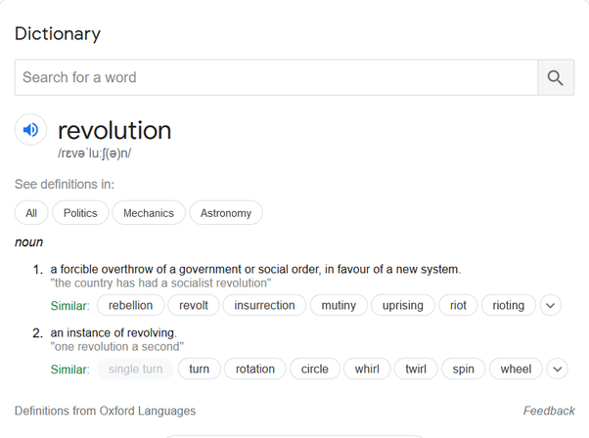

Maybe a better question can be “Why did IT revolution start in the US and why did IT create the most billionaires in US ?” . That would be a much better question. The answer is not as simple as you think.

Think of the creative destruction phonomena humanity has seen before which required lot of efforts:

* The first large buildings from Egypt
* Codified Law and Trade from Mesopotamia
* Civil Engineering from Indus Valley
* Mathematics from India
* Macedonian phalanx
* Greek Philosophy
* Principles of Empire Building from Rome
* Gunpowder and Silk from China
* Renaissance from Italy
* Spanish/Portuguese shipping
* Industrial Revolution from Britain
* Electronics breakthroughs from the US
* IT breakthroughs like telephony, satellites and internet from the US

Most of these phenomena did not stay restricted to the country they originate in, in fact, many of them benefited other countries more than the country of origin. They reason is discovering something is different from exploiting the new discovery. For example, Industrial Revolution originating from Great Britain actually made US industry base strong enough to emerge as the deciding factor in World Wars and hence as the new world power. Similarly, while Chinese invented the gunpowder, Central Asians (Turks) made empires out of it in Anatolia, India and Iran.

But there is one thing common amongst the countries inventing these technologies :

They were all rich and superpowers of their time. Rich countries have rich people who have money and resources to invest in a new technology development, so that they can benefit from being the early bird. Money drives inventions and luck drives who profits most from these investments.

TL,DR: IT revolution happened in the US because in the timeframe of 1950–now, US is the richest country with rich people who can invest into things that can give them profits. Being Rich also has basic requirements of stable government, rule of law etc. Greed is not always bad. Adam Smith stuff !

### My answer to “How did China become the world’s second largest economy with the help of reverse engineering?”

Originally Answered Here: <https://qr.ae/pNMVYl>

Good Question. One line answer is that you cannot be good at everything at the beginning, you start with one advantage you have and then use it to place your eggs in other baskets. China used its one well defined strength and advantage and is now finally in a state where it can look into developing new moats.

China’s advantage was its cheap/humongous labor force and united population ( achieved by the not so famous [Cultural Revolution - Wikipedia](https://en.wikipedia.org/wiki/Cultural_Revolution)

) willing to rally behind their country/leadership in any decisions they make. [Deng Xiaoping - Wikipedia](https://en.wikipedia.org/wiki/Deng_Xiaoping)

’s government skillfully engineered this “people’s republic” advantage into Market-Capitalist principles, creating the “factory of the world” we see today. China had population advantage and they used it well. There are other advantages/moats like capital/research/technology that you suddenly cannot create. People need to get better off, stock money, be able to go to universities (within and outside country) and be willing to invest and work in their own country for a country to develop these specialized advantages.

Using its first advantage, that is large and willing to work for country population, China developed a LARGE middle class, creating incentives for businesses that created rich people and capital and scholars in their own universities or scholars that went to top US universities and decided to come back and work. Now that technology/capital is plenty, China is evolving from what you are calling a “reverse engineering” economy to a first world innovation based economy. China is right now somewhat like how US was at end of World War 2. It has capital that it can invest in other places and take advantage of their growth (Africa/Central/South Asia/South East Asia) and build capabilities/afvantages which are more resistant to creative destruction like technology,science,space. [“Made in China 2025”: China's answer to Industry 4.0](https://www.europeanchamber.com.cn/en/upcoming-events/11057/_Made_in_China_2025_China_s_answer_to_Industry_4.0)

[Belt and Road Initiative - Wikipedia](https://en.wikipedia.org/wiki/Belt_and_Road_Initiative)



[Made in China 2025 - Wikipedia](https://en.wikipedia.org/wiki/Made_in_China_2025)



BTW, this is not a unique strategy, all world powers have arisen through this principle :

1. Develop one or a few unique advantages and come ahead of the world,
2. Conquer/Dominate the world and learn of other cool technologies/advantages people groups have,
3. Copy/Better the advantages of other people becoming prominent.

Mongols won a huge empire using their unique warfare methods, but slowly adopted traditional Chinese moats like Silk / Tea trade, Chinese engineering and irrigation technology.

[Kublai Khan - Wikipedia](https://en.wikipedia.org/wiki/Kublai_Khan)

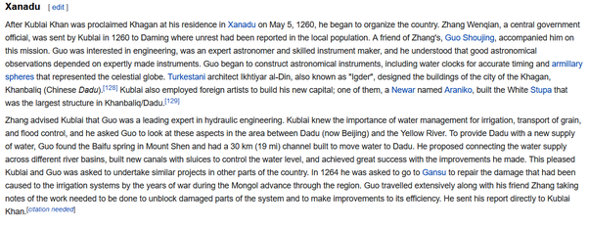



British developed Navy and came to dominate trade becoming resourceful, then they conquered India / dominated China and forcefully took their advantages under their own control (started making clothes in UK, started growing tea and silk in India and stated growing spices in caribbean ).

[Textile manufacture during the British Industrial Revolution - Wikipedia](https://en.wikipedia.org/wiki/Textile_manufacture_during_the_British_Industrial_Revolution)



That was the 18th century equivalent of China stealing IP (or what you call Chinese Reverse Engineering methods). [Intellectual property in China - Wikipedia](_blank)

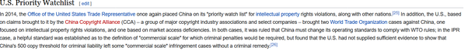

US did the same with Europe and UK, basically using investment and technology to develop a large industrial/financial base and then coming to capture trade/commerce/softpower/top technology after UK became a secondary power post world wars. As an Indian born near economic opening up of the country, I hardly find any connection to erstwhile empire my ancestors lived in, but many to US contemporary culture.

[Allied technological cooperation during World War II - Wikipedia](https://en.wikipedia.org/wiki/Allied_technological_cooperation_during_World_War_II)



China did the same thing. Using the investment from US elites looking to “globalize” and their willing workforce as low cost labor, they got their initial advantage and are now taking up the advantages US and other countries have in terms of technology.

### My answer to “Can inheritance be called nepotism?”

Originally Answered Here: <https://qr.ae/pNolgo>

No. There is a clear distinction between inheritance and nepotism from how I see it.

Inheritance is the transfer of wealth one has earned lawfully in their life to their progeny or kin. The wealth has been earned and is owned by the person who is passing it down. When one owns money or property legally (that is they have not stolen it and have paid taxes), I think its upto them what they do with it, whether spend it or save it and pass it on.

Nepotism on the other hand, is using one’s power and social status to do gatekeeping. That means using one’s power to create resistance for outsiders to reach the same or similar positions of power. For example, (what is in news in India these days), rich Bollywood personalities may deliberately use their connections to get their kids act in more and more movies while reducing chances for others. Another example is a politician’s kid getting preference over a similar (or even more) qualified people in politics, just because of connections of their parents. The reason is that the minimum requirement for most jobs, except the ones at apex/absolute top are average joes, so you wont feel the effect of a less effective person in the job, unless you contrast it with a very effective person sitting on the job. For example, someone sitting at a clerk’s position because they have contacts won’t be necessarily bad and you will notice the difference only when you see a very smart clerk work. Nepotism uses this fact to sneak in less qualified people due to the contacts. Its not always sneaked in btw, sometimes people are very open and blatant about nepotism.

All people want is if they are able to overcome their social obstacles to become as good as people from better families than them, they are pushed behind just because they come from less influential facility.

Nepotism according to me is unfair (and thus wrong) because:

1. While wealth is lawfully earned and possessed and the person has the right to do whatever with it (burn/donate/spend/save it for the kids). Inheritance is the exercise of this right. Its not necessary they use the wealth optimally for society or even themselves.
2. Status, influence and power is earned but is not possessed. In a meritocractic society, status is given to a person for their capability and is not possessed like in a monarchy. Influence is shared property of the person with influence and the society which gives them influence. They are not justified in using the influence in a way that is sub-optimal and bad for the society. People doing nepotism are basically cheating the society.

Nepotism nullifies the most important basis of meritocratic society that is “equality of opportunity”. In monarchies and other hereditary form of government, nepotism is built in and hence they enjoy low to no citizen-satisfaction and loyalty. Many people would not even mind if a monarchy who doesn't hear their voices be replaced. Try toppling a meritocratic society and see the retaliation !

Going against inheritance is basically going for “equality of outcome”. Equality of Outcome has fundamentally flawed assumptions that dont survive evolution human society :

1. People dont love their kids more than they love the kids of others. Life would have not evolved if this wasn’t true.
2. Equality of outcome finishes the incentives of risk taking people. Most human progress is because someone dared to light the first fire, tame the first wolf (all dogs are basically wolves), sit on the first immature assembled airplanes and touched radioactive elements without adequate protection (Marie Curie actually due chronic radiation poisoning) .
3. Humans are better at different things and we cannot expect them to be equally good at everything. Someone cannot be either a good engineer or good doctor or good politician, maybe one of these or two at best.

### My answer to the question: “Is nepotism in democracy a boon or a bane?”

Originally answered here: <https://qr.ae/pNuBxW>

This should not even be a question.

***Nepotism is of course bad for democracy.***

What everyone needs to understand is Inheritance is not Nepotism. People do not speak out openly against nepotism because they confuse the two : [Can inheritance be called nepotism?](https://www.quora.com/Can-inheritance-be-called-nepotism) Nepotism is using trust given by the public in a way to benefit one’s near and dear ones and thus harming the society as a whole. Inheritance is passing down wealth one rightfully earned to ones’ progeny. There is a reason in any decent government, office can be taken away for malpractices, but not one’s honestly earned wealth. Public trust and ability combined makes an influencer, not just their personal attributes, hence they cannot use their influence like personal property for decisions suboptimal to society.

**Why is Nepotism bad ?**

The biggest problem with measuring the effects of nepotism is that its hard to :

1. **Identify when Nepotism is taking place :** While the very famous cases cannot be hidden, many other cases are hidden well. Many public figures who appear to be rich and famous all due to themselves, often have used their parent’s connections. This makes it really hard for common people to associate talent with meritocracy. “All ABC officeholders are same” type of mentality benefits nepotists.
2. **Recognize mediocre public managers in short term :** People incoming from nepotism are often mediocre (otherwise they would not need nepotism), but they tend to be well informed (because that is what is going to save them from humiliation). They will hide behind rules, be good at public dealings and people pleasing. The aim of mediocre people is “to not get fired” and not “to do their job well”. Hence its harder to single mediocre people. So to normal people, they would look more acceptable. Looking acceptable is good way to run away from performance/responsibility.
3. **There is no control experiment for performance of a nepotism user (No one to compare):** Its very hard to know if someone has used nepotism to get ahead in life, its even harder to know what would happen if someone with merit would run the show instead of someone taking advantage of their name. Coming from an influential family gives people more risk appetite allowing them to compound more skills. The only way to understand if an actor from middle/lower class of society will be as famous (or actually more famous) as one from an influential background is to give them the same risk appetite (say get as many movies where they continue to not act well before acting clicks to them). That is not really possible. People can identify thus only blatant cases of nepotism, when the person being pushed ahead is so bad they cannot even hide their incompetence.

This study of nepotism in politics <https://www.tandfonline.com/doi/full/10.1080/2474736X.2020.1781542>

finds an interesting relationship. The percentage of people in administration who are relatives goes up with more number of municipalities jobs.

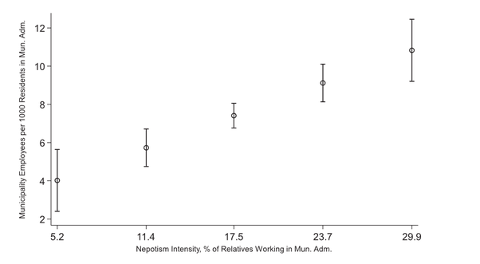

While the number of people who are relatives increasing with number of government jobs is obvious as “more people being hired means more people related to each other can be hired”, but the percentage of related people going up with larger number of job basically means, for larger municipalities, relatives are more likely to get hired !

The authors characterize nepotism as “Rent Seeking” by influencers, who when they cannot convert whole of their influence into money (because as I said, influence is a shared trust between influencer and influenced and not a cheque to be cashed), use their influence to get their relatives to become influencers too.

There is also a hint that the government is made bigger (and more inefficient) by overhiring to accommodate nepotism. In my experience, people using nepotism often want to protect their image by hiding behind degrees and expert opinions to save themselves from responsibility of their action. I think one way to use your influence and get relatives hired is to use money to get a degree and get them a job as an expert/consultant and the other way is to hire a lot of intellectuals who can create an environment to defend your policies and nepotism. You need overhiring in both cases. But that makes system inefficient for common man.

There is no doubt that nepotism over meritocracy would get more mediocre people hired. (not all people using nepotism can be meritorious!). Managers with perceived traits of mediocrity have been shown to have bad collaboration and yield. (This study is a bit too subjective to determine mediocre managers so take it with a grain of salt) : <https://www.researchgate.net/publication/242221207_What_Is_Managerial_Mediocrity_Definition_Prevalence_and_Negative_Impact_Part_1>

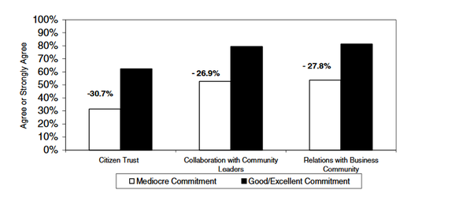

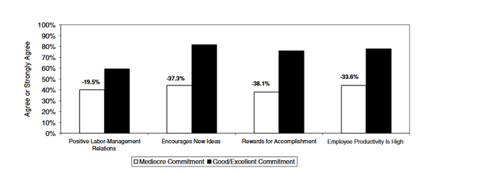

So, according to this study, mediocrity reduces productivity and cohesion in the long run. This is because mediocre people are bad at taking responsibility and initiative. These are also very common in nepotism culture by using safety as an excuse to avoid action and building an environment of “the whole system is slow and corrupt” to hide one’s inaction.

### My answer to “Doesn't Communism inherently provide no motivation for working very very hard?”

Originally answered here : <https://qr.ae/pNzS45>

**Short Answer**: “Yes”. Non-motivation to work hard is what caused the Soviet Union to fail.

**Long Answer**:   
What is the motivation to work “very very hard”?   
There are two reasons in my opinion:   
A. Emotional Connect (what we call passion) and   
B. Desire to get lucky (and thus get exponential returns on one’s efforts).   
If one of these two things don’t exist (or sometimes even both together), all a person will do is what you call 9 to 5 job. Now, there are of course people who are passionate about their work and will continue to work hard even if there is no gratification at all. However, emotional connection with one’s work runs into many many dangers at the micro-level, conflict with a boss, frustration with progress in research or any other conflicts can cause this emotion to dry off. The only thing that keeps people involved in slow-moving unyielding boring work is the hope of making it big. If you can possibly make it big, your family and siblings and you will have a much better future than they have now.

Now think about boring tasks like say bricklaying. Why would someone possibly be passionate about it? One is doing the job to put bread on the table, that is all. The only way they can be motivated to work really well at it is to show them how could they one day possibly make it big say have their own bricklaying company.

Communism, however, says you work hard and everyone will have a good house. ( [From each according to his ability, to each according to his needs - Wikipedia](https://en.wikipedia.org/wiki/From_each_according_to_his_ability,_to_each_according_to_his_needs)

). That builds really good momentum in the start as people are emotionally connected to their labour changing community. (You can see it in any communist/socialist regimes early days). However, that is really hard to pull off in the long term, one person working hard is not even sure to make just that one person’s living condition better, putting the burden of the entire country on them would basically make sure that their returns are either delayed or diminished. This kills of motivation to “make it big!”.

What I have written is “Communism by the book”, combine it with the gatekeeping done in the name of “loyalty” to “revolution of the people” and it gets worse.

The only people under Communism are people who are lucky enough to work in a field that they like and are not very affected by returns. There is a reason the Soviet Union could build a Space Shuttle (the only country apart from the US to build it) but was unable to construct a building on time to keep these shuttles. (This was the opinion of one of the Soviet scientists interviewed on many Buran documentaries I watched as a kid) There was no reason for the people making the hangar to work hard, unlike scientists working on the space shuttle.

Communism would be crazily successful if it can solve the problem of motivation.

### Q. My answer to “Is democracy still a good form of governance in the era of artificial intelligence where behaviour of mases can be predicted or influenced?”

Originally answered here: <https://qr.ae/pNiLaG>

I don’t think one can answer this question without getting political, but I will try to quote others mostly rather than giving my own opinions.

“*Is democracy is a good form of governance ?”*

Yes, it was probably the best when modern democracy was invented in US/France and for the next 250 odd years (which is till now). There is no better form of running a system than consensus among its components (which is people in a society). Democracy is the closest we can reach to consensus until now and even sometime in the foreseeable future. [Consensus Building and Complex Adaptive Systems](https://www.tandfonline.com/doi/abs/10.1080/01944369908976071)

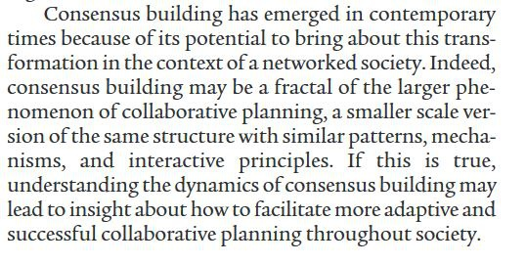

Democracy was envisioned as a way of building consensus among people about how they want their government to run. It was built with good intentions, “all men are equal”, “most deserving person would be the king” and later it adopted things like “minorities should have human rights” and “women should be considered to equal to men” and so on. If you look at human evolution, all these are relatively new concepts and these were adopted in liberal democracies.

However, the fundamental aspect of democracy was consensus among people to run the government. Consensus was not something that appeals to many people, but “Republic” does (one of our own ruling the country) does. To think of that someone from among the common people can be the ruler one day sells very well to common people.

The trick of running government for an elite in democracy was to use the information disbursal methods available (MSM like TV, radio, newspaper) to manufacture consensus. US and France developed the ways to run democracies and being world powers (France in 1800s and US 1940 onwards) exported the political thought. When you look at it, very rarely are the elected leaders from among common people.

In UK, you have [Oxbridge - Wikipedia](https://en.wikipedia.org/wiki/Oxbridge" \l "Criticism)

and [PPE: the Oxford degree that runs Britain](https://www.theguardian.com/education/2017/feb/23/ppe-oxford-university-degree-that-rules-britain)

.

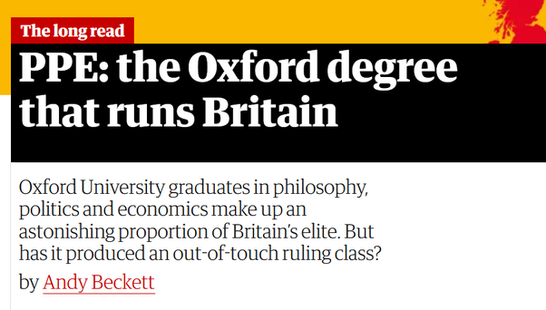

In other countries, you have political dynasties :



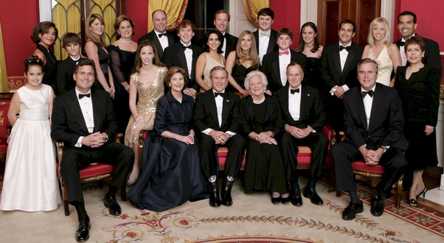

Democracies are built around shielding and decorating these leaders elected from “among the people” as ideal. No one wants to be ruled by the neighborhood a$$hole. If it sounds like conspiracy theory, we can look at Herman and Chomsky’s work : [Manufacturing Consent - Wikipedia](https://en.wikipedia.org/wiki/Manufacturing_Consent)

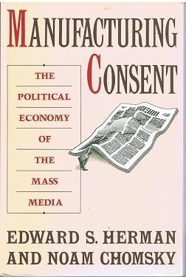

The entire premise of the book is that MSM is what makes democracy runs. Basically by highlighting facts selectively and sometimes just by lies. Chomsky claims that that the entire War on Terror thing was sold to Americans by the media. (So basically he says they could have just killed Osama-Bin-Laden in retaliation of 911 rather than attacking and capturing Afghanistan and Iraq). I was a kid when this happened, so I don't remember anything about what US media used to say about Afghanistan then, but I suppose funding such a huge war would have taken some convincing to do.

All I remember is Hindi media making America attack Afghanistan thrice before they actually did and showing F 117s on TV !

I am not trying to portray that elites do gatekeeping only in democracy, that is the reason why people got into the concept of democracy as they thought elites used to run the country in traditional monarchies. Here is a drawing from French Revolution :

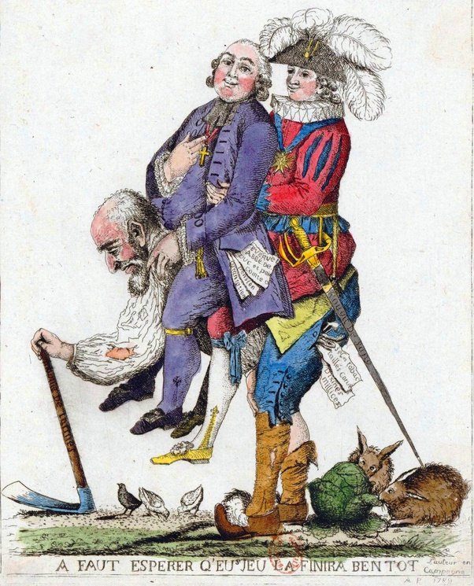

Whenever, people are tired of their elite, they will look for new ones. Elites who favour government run economy vs those who favour large monopolies. Elites who rule through a royal family vs those who rule through a republic. Quoting Naval Ravikant :



- [Wisdom From Naval Ravikant](https://moneyfyi.wordpress.com/2020/05/27/wisdom-from-naval-ravikant/)

I would say democracy as such is finding it hard as the human society it sought to run has changed drastically in last few decades than from earlier. The means of information disbursal have changed ! The tools that made liberal democracies tick are now doubted by many. Now the few ways for liberal democracies to go ahead are : A. Adapt to this new information regime. B. Resist the rapid spread of information or C. Become Irrelevant and wither off.

In words of Naval Ravikant again (will not quote him henceforth in this answer, I promise) :



If democracy goes, we will just be switching to new elites, whose policies we think are better for us, just like in 20th century we thought that democracy was better for us people than monarchies and colonialism.

“*Masses can be predicted or influenced”*

Was there ever a time when they weren’t influenced. Social Media/AI/Internet is just a more efficient tool to do so. That is the reason why disrupted old medium (plain old authority/ TV, newspaper cry foul about modern means, as they can distribute much more viral information in a much better way). It was never like that masses weren’t lead or predicted. Some more details in my other answer here:

[Muktabh Mayank's answer to Is artificial intelligence already controlling us in the form of tech giants manipulating people via algorithms?](https://www.quora.com/Is-artificial-intelligence-already-controlling-us-in-the-form-of-tech-giants-manipulating-people-via-algorithms/answer/Muktabh-Mayank)

I interacted with Economist Branko Milanovic on Twitter regarding this

Facebook didn't break democracy. It just made people mode aware about the dirty reality !   
Solution is not to stop Facebook, but rather redressing grievances of commoners. <https://t.co/e0LpP8Dxi2>

— Muktabh Mayank (@muktabh) [August 29, 2020](https://twitter.com/muktabh/status/1299814184410963968?ref_src=twsrc^tfw)

He believes that all social media (and other modernities like internet) has done is expose the dark underbelly of democracies rather than actually creating any problem themselves.

That's so obvious! Incredible there are people who do not see it

— Branko Milanovic (@BrankoMilan) [August 29, 2020](https://twitter.com/BrankoMilan/status/1299814496362475523?ref_src=twsrc^tfw)

Regulating Social Media will just transform it. Democracy either needs to adapt or be replaced. There is no way it will be able to stop progress. Humanity has defied all other concepts apart from progress.

### My answer to “What will happen if India embrace meritocracy?”

Originally answered here: <https://qr.ae/pNaNH3>

I saw this question a few days back when I was reading about the topic. What coincidence ! As a founder, you take time to read and finish things and so did this one and hence answering today.

My views about Meritocracy have changed a lot after reading the recent book by Markovits. [Daniel Markovits - Wikipedia](https://en.wikipedia.org/wiki/Daniel_Markovits)

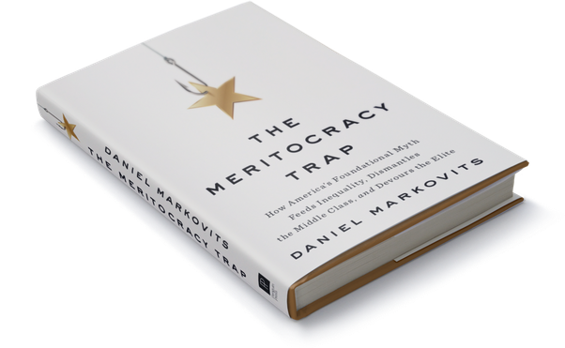

While there was a lot of hype in media about the book which somehow makes “meritocracy” sound like a bad thing, but that is not the message I took out of it.

Some points I see coming out of it (specially in the context of India):

**(Unlike what we think), Merit often doesn’t really measure innate intelligence**

“Merit”, unlike what most people would intuitively believe is not always innate. There are a few [Child prodigy - Wikipedia](https://en.wikipedia.org/wiki/Child_prodigy)

that do make it big, but try and remember the smartest kid in your school, are they really the most successful people when your school alumni association meets ? Not too often. Another very important point, when you are studying at the nation’s top institutions, like say IITs or IIMs (specially IIMs, which test students on many criteria than just on class 12 maths/science in IITs, which is somewhat of a equilizer) , how many people do you see coming from tier 1 cities, tier 2 cities and tier 3 cities ? Let’s look at other top institutions : NLSIU, NIFT and so on. IMO tier 1 and tier 2 cities are much more heavily represented than tier 3 cities and villages. That said, more people live in tier 3 cities and villages. A lot of people who come to top institutes from say a village often make a conscious choice about moving to a city to complete their education. Remember the word “choice” from here. What I want to say is that conditioning/environment is almost always more important than sheer innate intelligence one is born with. People don’t like to believe that, but that is the truth. Let us talk more quantitatively. The universities system of US, which most of the Indian middle class treats as some kind of beacon of “meritocracy” is almost totally biased towards rich kids : [Income Segregation and Intergenerational Mobility Across Colleges in the United States\*](https://academic.oup.com/qje/article/135/3/1567/5741707)

. I mean its pretty clear what is going on here:

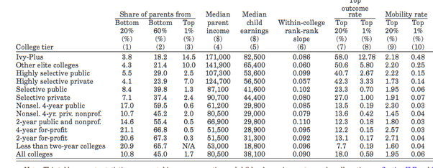

Most Americans attending their top universities are RICH ! Most poor kids won’t reach the top colleges (colleges which are supposed to change one’s fortune). And its not because the system is rigged, No. Rich kids are just better trained and conditioned and they become better than the poor kids by college admission age. I am pretty sure this division is in India too. More rich kids than poor ones are successful, more rich scheduled caste kids than poor schedule caste kids (the poorest of poor in India) are successful. And its not because the system is rigged, better environment, better coaching/tutions etc over many years compound to make the rich kids actually much better. They are more meritorious. Innate/Natural genius and talents seldom carry a person for their whole life.

**Meritocracy is thus not what most people think**

Meritocracy was meant to be a system of government where the meritorious come up due to their innate talent and lead the world. What actually happens is the people who actually come up as leaders are not the ones who are the most talented but the ones who are desperate about becoming a leader. There are many shortcut/hard ways to game the accepted process which makes one the leader.

So there are “Social Climbers” ( [Parvenu - Wikipedia](https://en.wikipedia.org/wiki/Parvenu" \l "Social_climber)

), promiscuity : [Shocking number of Americans have sex at work](https://nypost.com/2018/06/14/shocking-number-of-americans-have-sex-at-work/)

,

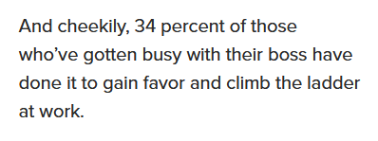

sheer brute force (violence is not unheard of in politics), just looking good (fashion / being born beautiful/ plastic surgeries) : [The Truth About Why Beautiful People Are More Successful](https://www.psychologytoday.com/us/blog/games-primates-play/201203/the-truth-about-why-beautiful-people-are-more-successful)

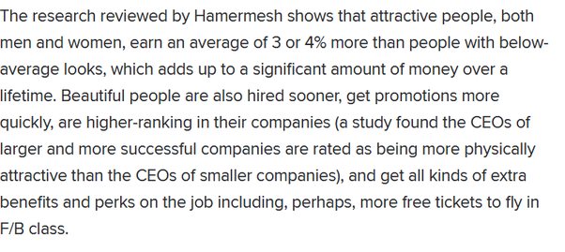

and lifelong practice. The more time one can take out of their schedule and practice, the better they can get at their skill.

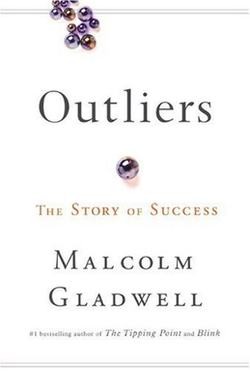

[Outliers (book) - Wikipedia](https://en.wikipedia.org/wiki/Outliers_(book))

This hardwork rule (or 10000 hour rule of success) is what most people accept and acknowledge among other ways to game the meritocracy system. Someone who wants to get on top will need both A. To practice hard and B. To address their weaknesses during this practice (for 10000 hours as you can guess) and become undefeatable in the field.

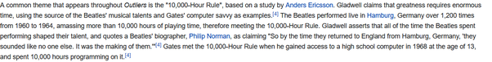

This means two things, the society and surrounding should be willing to give individual enough time to focus for 10000 hours (that is rare depending upon how demanding the situations one lives in are) and provide mentorship to help them identify their weaknesses (its hard to find good mentors for everyone). To describe a limiting case, you will not be a mathematical genius if you solve the same maths problems repeatedly for 10000 hours. So, an oversight can help channel hard work into success more often.

A more day-to-day example I would give from Indian meritocracy is the emphasis on exam scores to be successful (get internships, get into a good college, get a good job). The people who work hard to become good at a subject, will become good at it, but will not necessarily get better marks than someone who has spent all their time and energy in making sure they would score well in exams. There are ways to be more efficient to score better in exams, looking at last year papers, focusing on parts of course where solving questions is easier and choosing subjects to give an exam wisely. India’s meritorious people are thus who are able to work hard get good scores in exams (which is possibly still more meritocratic than people who can influence others becoming meritocratic say like in US, you can use looks/pedigree and many other things which even bypass hardwork).

India’s top exams , which selects people who would run India for their life: [Indian Administrative Service - Wikipedia](https://en.wikipedia.org/wiki/Indian_Administrative_Service)

, is easier to get through in some subjects than others. This hack has been used for really long and is an open secret. {Even I know it being an outsider}. Now whether someone is good enough at psychology is a good indicator of them being good leaders is a different question, but you should understand that gaming “psychology exams” is much easier than proving “Leadership Skills” or what the army calls OLQ : [What Are Top 15 OLQs- Officer Like Qualities](https://www.ssbcrack.com/2011/07/top-15-olqs-officer-like-qualities.html)

. Army officer selection is relatively less transparent due to this.

[Which Is The Most Opted Optional Subject In IAS?](https://www.careerindia.com/tips/which-is-the-most-opted-optional-subject-in-ias-022161.html)

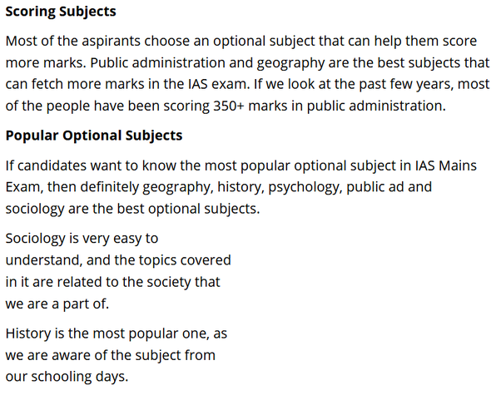

So, frankly, Meritocracy is the class of people who can game the system well. No one is really going to get ahead by “innate” characteristics.

Before one makes an opinion like “f\*\*k riiich people”, looking at the thoughts above, let me clarify that I am not saying that the system is rigged. Its not, meritocratic people just optimize to get the best gain out of the system. Another thing is not all rich people are meritocratic, I will describe who exactly forms the meritocracy according to the book in next section. I will also describe what exactly does meritocracy functions. Unlike being wealthy, anyone can be meritocratic and climb life’s ladder.

**Who are meritocrats**

As I said earlier, being meritocratic means being capable to game the system. Keenly observation about what optimizations yield better returns than what an average person is doing and placing many such bets gives accumulated benefits. Modern meritocracy is basically investing into kids to convert them into very refined products. Be in no doubt, Indian parents (specially Indian middle class parents) are very good at that and that is why ***India is quite close to a meritocracy***. They recognize importance of good guidance and investment to make their kids good at skills that get them non-linear returns. So are jews and other asian communities (at least the tiger mom stereotype I see on media). Indians might have a lack of information and resources (which is a different problem), but boy they invest money into their kids’ future much more than what they are capable of. Where they spend that money though keeps changing depending upon the perception that is created in their minds around the success landscape. IIT coaching classes when I was in high-school and WhiteHat Jr now 15 years later in 2020.

**Meritocracy is a choice**

Another thing one needs to realize is that any system can be gamed. Most liberal democracies, colonies before them, monarchies all of them. Also anyone can game the system. This is unlike wealth, which is harder to collect at level ZERO. One just needs to make sure their kids are really good at a few things (that the world demands) they are not good at. In India, this is so common that its not even a talking point. There are cultures where this is rare btw. But there are problems like wrong perceptions about where investments need to made, how much investment of time and money and what exactly is in demand.

One thing one needs to understand is that wanting to be meritocratic is easy, being meritocratic is hard. To be meritocratic, one needs to invest disproportionately into making their kids irresistible to the world. Not making them pampered and entitled. The kids brought up to be irresistible will have less social interaction, will spend more time at practice than having fun, will have to make delayed gratification decisions all their lives and will always have to strive to get better. There small profit making decisions aggregate to give them very high returns than average kids. Markovits explains it much better in the book than how I explain it here, maybe in not as much of a positive context. This is a marathon and not sprint, some parents will not be sure why their kids are not successful after they bought them a degree (or they got them into a movie), the reason is they can buy momentary degree or opportunity, but they cannot buy “needing their kid” from the world.

Basically, its a choice. Do you want to get ahead, than have less fun and plan according to future. I explained in another answer how many Indians make multiple loss making decisions in their lives : [Muktabh Mayank's answer to What do people who are more than 45 years old do after getting fired from their job due to cost cutting?](https://www.quora.com/What-do-people-who-are-more-than-45-years-old-do-after-getting-fired-from-their-job-due-to-cost-cutting/answer/Muktabh-Mayank) . To move ahead, one needs to cut them down according to both Markovits and Gladwell.

As you can guess, this is not going to be easy and a lot of people will not be able to suppress themselves all their lives. That is where meritocratic people win. They sacrifice their today for big gains in future, which most other won’t do. When you hear “rich keep getting rich”, you need to understand that the same people and families don’t stay in the “rich” bracket over time. Rich people of 2020 are richer than Rich people of 1920, but they are not necessarily the same families. Some meritocratic families would still be there, many new meritocratic families would have entered, some families would have squandered their wealth away.

**Meritocracy is a very powerful moat, just like Aristocracy**

Ok, this is possibly the thoughts from Markovits’s book that creates controversy. He says while some people would want to game the system and move ahead whatever it is, others would just want to have similar returns as the meritocrats. This would create friction in society, because :

A. Non Meritocrats wont really realize the amount of investment meritocrats do to make them indispensable.

B. Meritocrats treat non-meritocrats as idle freeloaders.

Possibly more so in America that has many parallel cultures, some very meritocratic and some not at all. In India, however, I don’t see a lot of this divide, people just value hard work. Maybe because of teachings of Gita or something : [Bhagavad Gita - Wikipedia](https://en.wikipedia.org/wiki/Bhagavad_Gita)



However, the recent nepotism debate after SSR’s death can be looked at with this lens. SSR is exactly what one would see as a meritocrat and people think of the obstacles in his career as slakers stopping a hard working person.

Look at what Sushant says in this Pew Die Pie video and try looking at the description of meritocracy :



https://youtu.be/FXTgITg-UAM

### My answer to “Why are imported goods sometimes cheaper than local goods?”

Originally answered here: <https://qr.ae/pNzSYn>

Introducing my man Mr. Economies of Scale here. [Economies of scale - Wikipedia](https://en.wikipedia.org/wiki/Economies_of_scale)

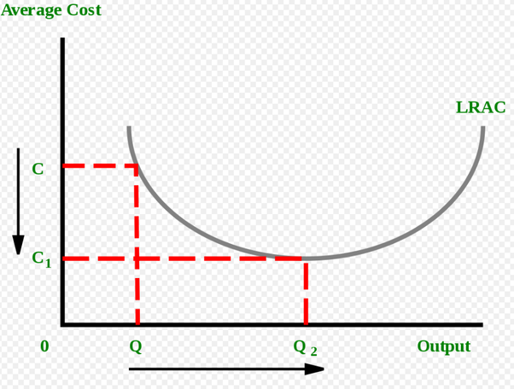

If two firms have the same technology and same marketing principles , then the one producing more quantity of products might have less production cost. This less production cost can be used to outcompete the rival by keeping goods of same quality cheaper or making more profit to develop better marketing and Research to outinnovate the rival. A multinational firm which is serving more countries has a headstart in the number of items produced and can use economies of scale to drown smaller companies.

Economies of Scale is a differentiator purely on the amount of products a company sells rivaling products of same quality, but there are other more prominent differentiators which won’t even allow a local product to be equivalent to a multinational firm’s product. Headstart in research, better machinery, more experienced managers than a local rival can allow a multinational company to have a very competitive price as compared to a local rival.

All factors above are ethical factors. Multinational companies with large amount of cash at hand might practice dumping [Dumping (pricing policy) - Wikipedia](https://en.wikipedia.org/wiki/Dumping_(pricing_policy))

to make sure that local rivals die giving them a monopoly.

### My answer to “If communism makes people poor, then why is China poised to become the world's biggest economy in 2028?”

Originally answered here: https://qr.ae/pNJvgf

Because China doesn’t follow “Communism”. China’s political ideology is [Socialism with Chinese characteristics - Wikipedia](https://en.wikipedia.org/wiki/Socialism_with_Chinese_characteristics) , which is not what Mao Zedong had in mind when he established the communist state in 1940s-50s. [Deng Xiaoping - Wikipedia](https://en.wikipedia.org/wiki/Deng_Xiaoping)

was a very pragmatic leader, who modified China’s brutish economy into the modern one we see today and he did by slowing transforming Communist economy of China into Political Capitalism. Xiaoping knew that communist policies would not work to get his people out of poverty, so he thought of using capitalism to achieve Communism’s goals : A. Drive people out of poverty, B. Maintain hegemony of the communist party. His famous quote “it doesn’t matter if the cat is black or white as long as it catches the mice” was given with this exact thought in mind.

<http://www.kropfpolisci.com/chinese.state.capitalism.pdf>

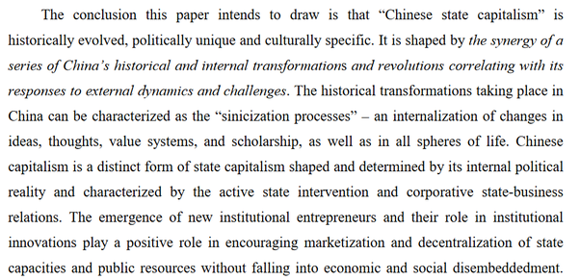

Most westerners {and Indians} would dread this idea calling it cronyism, but its working and is working really well for China. {and other Asian countries}. The idea for this form of economy came from none other than Singapore’s “anti-communist” premier Lee Kuan Yew and officials from Singapore guided China’s transition from “Communist Economy” to “Socialism with Chinese Characteristics”.

[Deng Xiaoping visited S'pore in 1978. Here's the impact it left on Sino-S'pore relations 40 years on.](https://mothership.sg/2018/11/deng-xiaoping-singapore-china-george-yeo/)

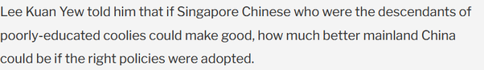

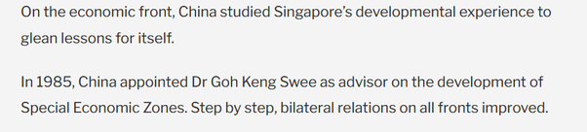

So no, China is not the “Communist” country like one would think of. Its not even close to Soviet Union, which was a communist economy. Its a pragmatic authoritarian regime, something that would be called fascist and crony of the rich if it were running in India.

### My answer to “As a result of the Fourth Industrial Revolution, will any job be lost?”

Originally answered here : <https://qr.ae/pNxz0V>

A few jobs will be lost, most jobs will change or evolve and many new jobs will be created IMO. This is not a new phenomenon, just continuation of human progress.

There are many jobs which existed during 20th century which don’t exist now :

[Finding a punkah-wallah, and other essential Raj tips: THE COMPLETE INDIAN HOUSEKEEPER AND COOK](https://www.dailymail.co.uk/home/books/article-1262627/Finding-punkah-wallah-essential-Raj-tips-THE-COMPLETE-INDIAN-HOUSEKEEPER-AND-COOK-BY-FLORA-ANNIE-STEEL-AND-GRACE-GARDINER.html)

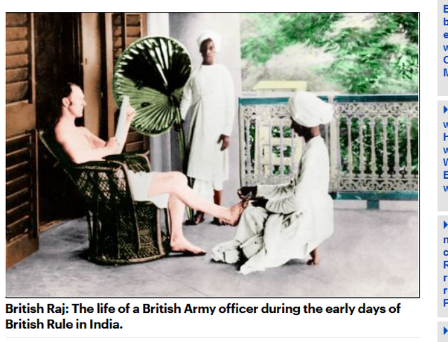

Look at the jobs Indians are doing in this photo during colonial times. Working a handfan and clipping toenails. Both these jobs don’t exist now. Due to electrical appliances and India no more being ruled by entitled white people unable to cut their own toenails, our people can focus on more productive jobs.

Similarly just a few generations back, if people had to send any important message, they had to go to this person :

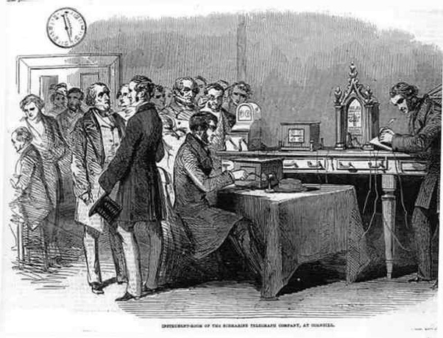

The telegraphist. My grandfather used to tell me that people went into a shock just by hearing they have received a telegram as they feared it would carry bad/emergency news. Most news that one could afford to send over wires required emergency action. Millenials in India {including me} haven’t seen a telegram in their life.

Let’s talk of something many millenials [and maybe Gen-Z’s would have not] would have seen in their life :



How many PCO operators do you see now ? As a kid, I remember using PCOs sometimes.

Technology changed jobs of telegraphists to PCO operators to SIM Card/Phone salesman/technician . Old jobs were replaced by new and more jobs. Was it painful or hard ? Maybe, but not as hard as what people imagine switching jobs is.

If you watched the movie Dum Lagake Haisha, you would have seen the jobs Ayushmann Khurana did in the movie. Recording songs on audio cassettes and how new technology [CDs in the 1990s] were slowly impacting his business and he decided to switch. This is how better technology and disruption impacting a job looks like. *It requires one to change and relearn, but is gradual and at a pace people can adapt to.*



When I was a kid [and this is long back, possibly the oldest things I could remember], I could get my favorite songs recorded on a cassette, 8 in one cassette. It was costly enough to have a discussion in the family about what songs are good enough to find a place in the cassette. If the “cassette recorder” found some extra space on the tape because the songs were relatively smaller, they would put a few bonus tracks ! While this is all good for nostalgia, what dismal piece of technology compared to today.

Let’s talk about jobs from India which are no more done now and most millennials have not seen anyone doing.

Bhishti or Waterman, who carried drinking water



Cavalry Soldiers :

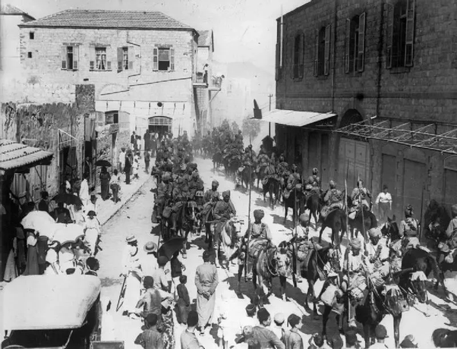

We don’t have anymore mounted soldiers because well they serve no purpose in modern warfare. Till the world wars, mounted regiments and lancers were important. The famous win by Indians in World War 1 was all by cavalry forces. [Battle of Haifa (1918) - Wikipedia](https://en.wikipedia.org/wiki/Battle_of_Haifa_(1918))

Even the jobs which have been around for a considerable time have evolved in scope and a literally new jobs now bearing the same old names.

For example, my ancestors who were clerks by caste had to learn three languages just to maintain records in British ruled India. That would have been too much work, juggling between Roman {to write English for the British sahibs}, Persian {because of previous Mughal Rule} and Devnagari {which was not standardized yet because no one cared about the native script, so they actually had a community level standardized devnagari script to keep documents interchangeable} just to keep accounts and records. How inefficient !

Now a days clerks are computer operators. I went in to get a driving license last month and all clerks had to do was fill online forms. [Jobs are not caste based in independent India, clerks now come from all communities] , I hardly think even the jobs that survive automation are the same jobs as ones pre-automation.

What I am trying to say that new technology has been making jobs obsolete forever and creating new jobs which are gradual progress from the old ones. Fourth Industrial Revolution is a name for technologies that would drive changes in the 21st century : AI, IoT, Blockchain, CRISPR, 3D Printing and so one. They will create new jobs which will be evolution of current day jobs but would make humanity more efficient. As long as we can ensure people can relearn and adapt to new jobs, it is mostly going to be fine. There is lot of sensationalism in the media which makes people fear that they suddenly one day become useless in the workforce, but they need to understand such things are not sudden and gradual. New technologies are made in a way that it is easy to learn for people already experts in that domain. So Chill !

Another fear that is being circulated is [Artificial general intelligence - Wikipedia](https://en.wikipedia.org/wiki/Artificial_general_intelligence)

just replacing humans from all jobs. That fear is like Aliens attacking Earth and making it a colony. It is possible, but it becoming true suddenly is not that high probability an event. Are we worrying about alien invasion and developing space warfare ? No. Current AI technology is : A. Gradual to evolve and B. Has limitations both infrastructure and theoretical. AGI with technology existing right now is not possible.

[It Turns Out, Humans Are Pretty Smart: Developing Self-Driving Cars Is Harder Than We Thought](https://tti.tamu.edu/news/it-turns-out-humans-are-pretty-smart-developing-self-driving-cars-is-harder-than-we-thought/)

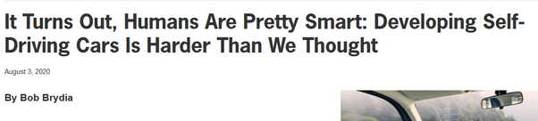

We will have AI aided driving very soon, maybe in 2020s. Even full self driving might be possible in special conditions. But replacing humans altogether is not a scenario I foresee. I can be proven wrong, but that is not how it looks right now.

### My answer to “I have never ever bought anything based on a telemarketer cold call or an email or text or an online ad. Why are corporations unable to discover this fact about me in this age of AI, Big Data and brazen privacy invasion?”

Originally answered here: https://qr.ae/pNaHUO

Good question.. web marketers / telemarketers / email marketers know that you are not going to purchase things on seeing ads. They are not mostly trying to sell to you, just trying to occupy some real estate in your mind. If you buy immediately or soon after seeing the ad or receiving the call, its a bonus, not the intention.

My remaining answer is my subjective interpretation of the following McKinsey article : [The consumer decision journey](https://www.mckinsey.com/business-functions/marketing-and-sales/our-insights/the-consumer-decision-journey)

Before information age, people had a specific set of brands to choose from. Say 3 brands to buy a car from , 5 to buy a refrigerator from and 10 to buy detergent from. This was a number buyers could remember and all these brands needed to do was explain their utility with respect to competitors and try to change decision of people who are going to make a purchase.

You would remember the more effective vs competitor ads on Indian television from 1990s. These ads were shown because people were pre-informed about the available brands and brands needed to pitch why they are better than others.

Customer however has become very powerful in the internet age. With internet marketing, D2C brands and supply chain becoming commodity, customers have many many alternatives. Customers are savvy and they will make an effort to read and find out and make a smart decision, but they should know what brands can they Google before a purchase is being made. Ads are targeting that real estate of your mind and memory. The brands bombarding you with information through internet ads and other marketing know that if customer knows that there are alternatives to something they bought recently, they will make the alternative a part of decision making process. The work of finding out pros and cons, value for money etc. customer will be able to do themselves by Google or even better watching reviews on Social Media or Youtube. All the customers need to be told and made to memorize is that there is a competitor.

### My answer to “How did Elon Musk manage to become the richest person in the world with companies that aren't even profitable yet?”

Originally answered here: <https://qr.ae/pND8uy>

Chill ! Don’t be so hard on a person who has actually done something about humanity’s future. Elon Musk’s businesses and ideas {Mainstream EVs, Hyperloops, Private Space Exploration, Satellite internet services, brain implants for human hivemind, OpenAI, Affordable Solar} are almost all going to change humanity for future directly or indirectly. I personally think he deserves being the richest man alive just for his effort.

I am pretty sure that the person who asked this question will need to understand how precarious situations for entrepreneurs are. Elon is very rich in invisible dollars, like you having a deposit in a bank you cannot cash for years, except that the deposit can crash & burn anytime. A lot of his wealth is just people speculating about how good a company can he build and he cannot even spend it, or even be safe in the fact that the wealth would stay with him forever. As a rich [or even small] tech entrepreneur, one’s wealth is just the valuation of their company which is determined by others who can someday stop giving the same value to company. Unlike say old-money people [royalty, politicians, celebrities], entrepreneurs have all eggs in one high risk basket. Having 1 Million US Dollars in a safe mutual fund is much more sure money than having 10 M US Dollars in equity valuation. Unlike old money, who have lot of money invested in safe places, almost all of a tech [or even other] entrepreneur’s worth is locked in their venture that can go up and down like crazy. Its much more validation than wealth. Not a bad thing to have wealth in the way entrepreneurs have [that basically means you are a leader and people believe in you], but seldom means you are super “rich” in sense common people think.

*Having shares in a high valuation company is not at all like founders have been rewarded with hordes of cash before they have achieved anything. All that means is people like them as leaders. If these entrepreneurs do well in future, they might eventually cash all their validation out. [That seemed like the central premise of question, how can they get rich if company doesn’t churn profit ?]* So unlike some oil barons, a somewhat successful startup founder cannot spend like there is no tomorrow, despite of being much worth than oil money they make.

Elon Musk has been trusted to become the best business leader of the world and thus he is the most valued man, but he is not really the “richest” IMO. He might eventually become the richest if he delivers.

### My answer to “Why do global stock markets rise even during an economic collapse?”

Originally answered here : <https://qr.ae/pNaYAl>

One thing that you might notice is that not all stocks are going up :

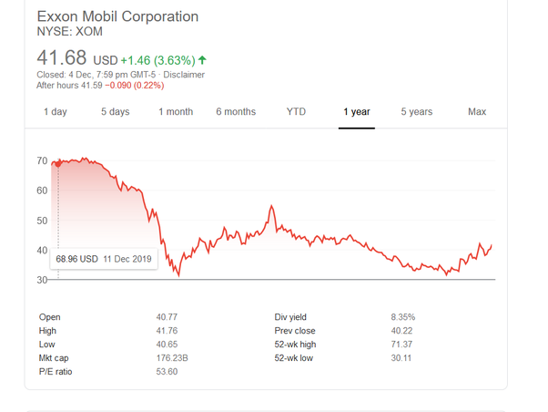

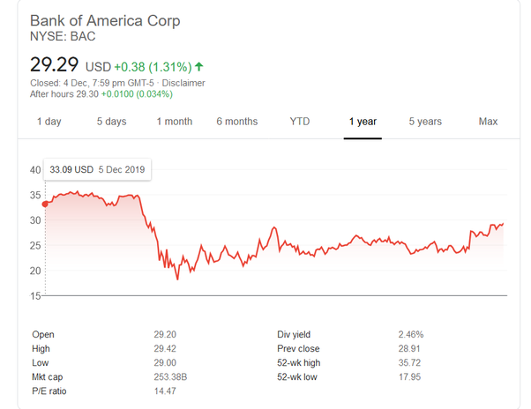

and some have hardly reached their pre pandemic numbers or around those numbers :

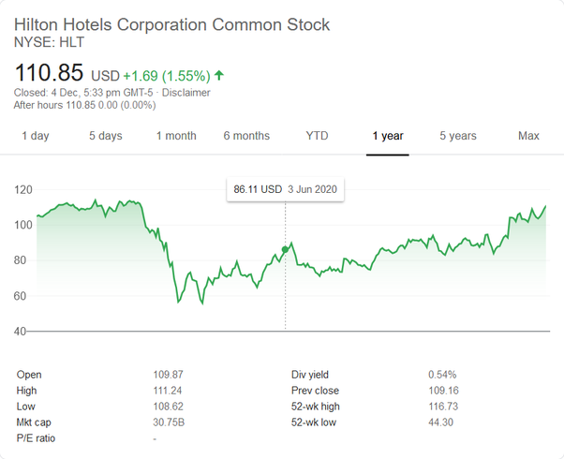

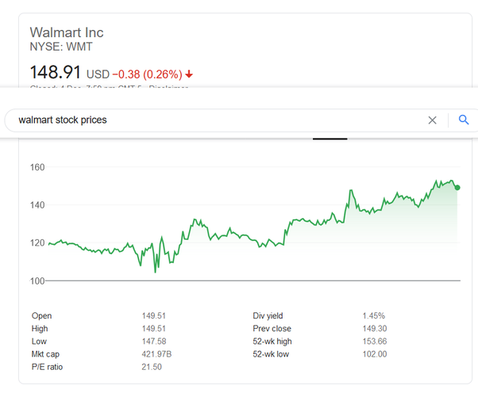

And while some of them are , whoa just look at the Y axis :

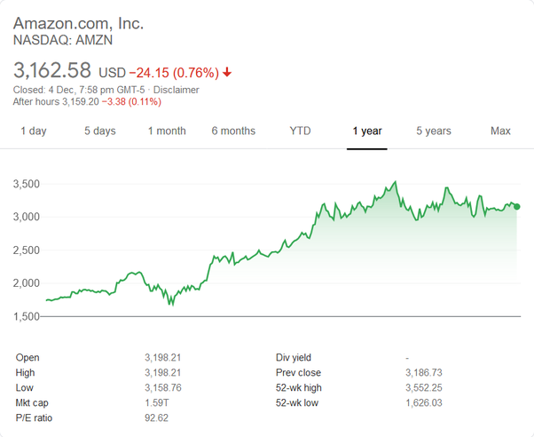

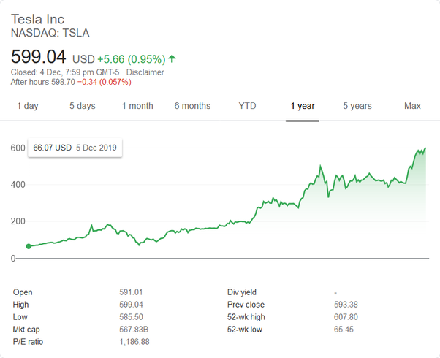

Investors are pouring money into stocks they think are going to lead the world post-pandemic. People have formed new habits and governments suddenly have much more power in order to keep the economy alive, the way they had after the world wars. So investors have recognized the trends and are investing to gain from the movement of humanity towards :

1. Tech trends like internet gaming, software, shopping and online / remote work will mostly continue.
2. Governments getting much more power to make economy survive would make sure fundamental changes in infrastructure would happen in lieu of old sectors getting redundant to keep economy in motion, (think renewable energy and electric vehicles). Just like post World Wars we had the American Highways and Marshall plan.

Governments also have printed tonne of dollars - [Quantitative easing - Wikipedia](https://en.wikipedia.org/wiki/Quantitative_easing)

(specially US government) to finance point 2 above and to keep the existing economy in motion (individuals will just hold on to their cash during crisis, so government prints more money and pushes it down the economy to keep people earning, [The General Theory of Employment, Interest and Money - Wikipedia](https://en.wikipedia.org/wiki/The_General_Theory_of_Employment,_Interest_and_Money" \l "The_Keynesian_economic_system)) .



While for some people this extra printed money will just make sure they don’t lose their jobs in a sector which is totalled and can put bread on the table, other people who accumulate some of this money will invest it into 1 and 2 (because they are sure to grow) reinforcing these trends. This extra money being printed + invested shows you growth in not just US market, but also other markets where money is flowing and is being invested.

### My answer to “Is economic disparity among countries driving Covid vaccine distribution inequality?”

Originally answered here: <https://qr.ae/pNJzV9>

I don’t think that is always true. There is economic disparity between countries, but its not a result of economic disparity that vaccinations will happen at different rates. IMO a mixture of economic policy and population’s approach to life is what gives countries different standing in terms of COVID vaccination.

For example, Russia which is the 11th largest economy and India which is the 5/6th largest economy but has a low per capita income number will be much more secure in vaccinations than many economies who have better per capita income than them. China is a wealthy country, but not wealthiest per capita and it would fare much better than countries richer than it. Israel is a relatively small economy but is leading the world in %vaccination. US already has secured enough vaccines for its entire populations, but their rate of vaccination is slow.

I think there are ***three things that when all combined together*** make a country more secure about vaccine :

1. High Purchasing Power, irrespective of the fact if the total economy is small or large. That is administering vaccine to a huge population is not super duper costly.
2. Having indigenous industries and not depending on other countries for supply chain. This means both production and supply catering to local demand.
3. Having an infrastructure set to drive vaccinations. You need efficiency in administering vaccines too.

So for example Israel will be able to close acquiring all required dosage by April.

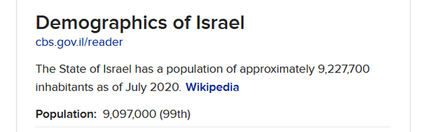

[Israel to produce 15 million doses of its COVID-19 vaccine, research institute says](https://www.haaretz.com/israel-news/.premium-israel-to-produce-15-million-doses-of-its-covid-19-vaccine-research-institute-says-1.9338501)



And given its speed of administration, its not going to take much more time for them to make the population 100% vaccinated :

We have just updated our [@OurWorldInData](https://twitter.com/OurWorldInData?ref_src=twsrc^tfw) COVID vaccination dataset: <https://t.co/lQZYjLUdPK>  
  
Israel has by now vaccinated 11.5% of their population.  
  
The country is rapidly getting to a point where mass deaths and mass lockdowns are over. [pic.twitter.com/GtRCHnYGmo](https://t.co/GtRCHnYGmo)

— Max Roser (@MaxCRoser) [January 1, 2021](https://twitter.com/MaxCRoser/status/1345036113925332993?ref_src=twsrc^tfw)

Compare this for example to the US, which already has all the required dosage and is much much wealthy than Israel :

We've become That Country where people shrug and expect failure and make excuses [pic.twitter.com/HvJqnUPl5z](https://t.co/HvJqnUPl5z)

— Noah Smith 🐇 (@Noahpinion) [December 30, 2020](https://twitter.com/Noahpinion/status/1344123825718325250?ref_src=twsrc^tfw)

US gets behind on 3rd point [its better at 1 and 2] as compared to Israel because of the bottom up way in which country is structured. States leading vaccinations might have been better maybe ?

Different countries face different challenges in vaccinations. While countries where 1,2 and 3 are available, these challenges are simpler like : “How to create confidence in the vaccine ?” and “How to subsidize the vaccine ?”. Countries lacking 1,2 and 3 have more basic questions like “How to outbid other countries to procure the vaccines fast?”, “Who will administer the vaccine ?” or “Where to get the money to buy the vaccines ?”.

While Russia is thinking of ways to create confidence in its vaccine :

[Russia starts its vaccine drive](https://www.dailymail.co.uk/news/article-9020827/Russia-starts-vaccine-drive-Nurses-Moscow-Sputnik-V-jabs-risk.html)





India is solving a cheap vaccine problem to buy and transport for its relatively less income population.

[COVAXIN will cost less than water bottle: Bharat Biotech MD](https://in.news.yahoo.com/covaxin-cost-less-water-bottle-144320669.html)



and it seems its close to achieving that goal : [A Phase 1: Safety and Immunogenicity Trial of an Inactivated SARS-CoV-2 Vaccine-BBV152](https://www.medrxiv.org/content/10.1101/2020.12.11.20210419v1)

Indian indigenous vaccines like COVAXIN above and COVISHIELD {OxfordAstrazeneca’s Indian variant} can be stored in normal fridges and dont require tempratures of -20 - -50 degree celsius like other vaccine. India is ready to press the paddle on vaccination too due to its homegrown vaccine advantage and competition.

Covishield rollout in a matter of days, likely by 2nd week Jan. Serum Institute of India (SII) has 50 million doses ready to move, and will be scaling up manufacture now. Big nationwide dry-run tomorrow. [pic.twitter.com/q23SsZOQmg](https://t.co/q23SsZOQmg)

— Shiv Aroor (@ShivAroor) [January 1, 2021](https://twitter.com/ShivAroor/status/1344985599267143682?ref_src=twsrc^tfw)

China has a similar advantage : [China OKs 1st homegrown vaccine as COVID-19 surges globally](https://abcnews.go.com/Health/wireStory/china-conditional-approval-sinopharm-vaccine-74981163)

The countries where all 3 points above : 1,2 and 3 are not followed, will have to face sporadic supplies, delays, high costs or going without vaccination.

Since we started talking a few days ago about vaccination rates, Israel has cheerfully accelerated by another 77%.  
  
US... dipped a bit and then kinda wiggled up a tiny amount. No clear trend.  
  
The EU has administered fewer vaccine doses (in absolute numbers) than Israel has. [pic.twitter.com/mBvGLAZTMB](https://t.co/mBvGLAZTMB)

— Patrick Collison (@patrickc) [December 31, 2020](https://twitter.com/patrickc/status/1344739686816903168?ref_src=twsrc^tfw)

Argentina, South Africa, Brazil, and Turkey — all countries that hosted vaccine trials — will have to be satisfied with Pfizer’s gratitude, because (like most countries in the world) they won’t be receiving enough of the vaccine to inoculate their populations anytime soon.

— The Intercept (@theintercept) [December 31, 2020](https://twitter.com/theintercept/status/1344670213846032385?ref_src=twsrc^tfw)

[Ukraine signs up for China's Sinovac vaccine, with doses expected soon](https://www.reuters.com/article/us-health-coronavirus-ukraine-vaccine-idUSKBN294150)

Mind you SinoVac is not the vaccine China has cleared for internal usage.



[Argentina Kicks Off Vaccination Drive With Russia’s Sputnik](https://www.bloomberg.com/news/articles/2020-12-29/argentina-kicks-off-vaccination-drive-with-russia-s-sputnik-v)

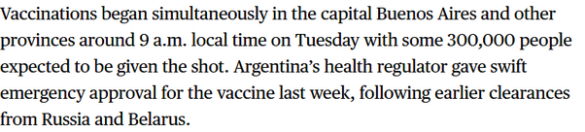

With these countries, you will see some kind of “vaccine apartheid” as intercept calls it. {I think that is a bit too extreme a narrative but still}. The richer, the better to survive.

World faces Covid-19 “vaccine apartheid” <https://t.co/JCxSHvmUDJ> by [@fastlerner](https://twitter.com/fastlerner?ref_src=twsrc^tfw)

— The Intercept (@theintercept) [December 31, 2020](https://twitter.com/theintercept/status/1344658810628149248?ref_src=twsrc^tfw)

Lessons for the future from here : “Being self sufficient is a good thing during bad times for basic things like food, healthcare, finance and education. Don’t kill off your country’s research and essential services thinking that the international free market will take care of everything.”